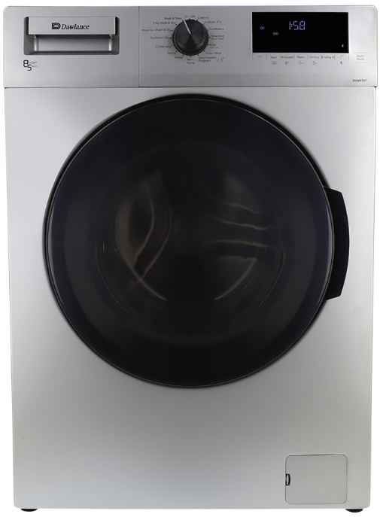

Dawlance Front Load Washing Machine
Rs.217,300
Dawlance DWD 85400 S inverter front load washing machine offers an 8 kg wash capacity, 15 wash programs, and a brushless inverter motor for reliable fabric care.

Specifications
- Model: DWD 85400 S
- Capacity: 8 kg
- Motor: Brushless Inverter
- Spin Speed: 1400 RPM

Key Features
- 15 wash programs
- Hygiene care
- Delay start
- Vibration reduction

